January １月

1st（１日）

Czech Republic: Restoration Day of the Independent Czech State

1st（１日）
Japan: New Year’s Day

23rd （２３日）
Japan: Coming of Age Day

26th（２６日）
Australia: Australia Day

26th（２６日）
India: Republic Day

Jan. 31st – Feb. 6th （１月３１日〜２月６日）
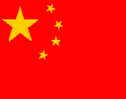
China: Spring Festival

February ２月

Jan. 31st – Feb. 6th （１月３１日〜２月６日）
China: Spring Festival

4th（４日）
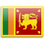
Sri Lanka: Independence Day

5th （５日）
Pakistan: Kashmir Day

6th（６日）
New Zealand: Waitangi Day

15th（１５日）
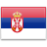
Serbia: Independence Day

24th（２４日）
Estonia: Independence Day

March ３月
1st （１日）
South Korea: Independence Movement Day

8th （８日）
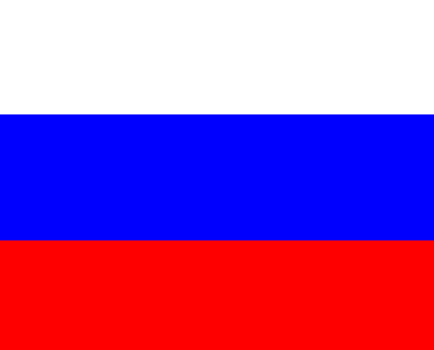
Russia: Woman’s Day

17th（１７日）
Ireland: St. Patrick's Day

23rd （２３日）
Pakistan： Pakistan National Day

25th（２５日）
Greece: Independence Day

26th（２６日）
Bangladesh: Independence Day

April ４月
14th （１４日）
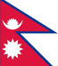
Nepal: Nepali New Years Day

14th （１４日）
Laos: Laotian New Year’s Day (Pi Mai Lao)

16th（１６日）
Denmark: Birthday of Queen Margrethe II

24th（２４日）
Ireland: Proclamation of the Irish Republic

29th -30th （２９日、３０日）
Japan: Showa Day

30th（３０日）
Netherlands: Koningsdag (King's Day)

May ５月
1st （１日）
Indonesia: Labor Day

1st （１日）
Pakistan: Labour Day

1st （１日）
Spain: Labor Day

5th （５日）

Netherlands: Liberation Day

9th（９日）
Romania: Independence Day

15th（１５日）
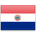
Paraguay: Independence Day

17th（１７日）
Norway: Constitution Day

26th（２６日）
UK: Memorial Day

June ６月

2nd（２日）
Italy: Republic Day

6th（６日）
Sweden: National Day

10th（１０日）
Portugal: Portugal Day

12th（１２日）
Philippines: Independence Day

11th （１１日）
Russia: Russia Day

July ７月

3rd（３日）
Belarus: Independence Day

4th（４日）
United States of America: Independence Day

11th （１１日）
Mongolia: Naadam Holiday

14th （１４日）
France: Bastille Day

16th -17th （１６日、１７日）
Pakistan: Eid-ul-Fitr

20th （２０日）
Japan: Marine Day/Sea Day

20th （２０日）
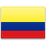
Colombia: Independence Day

28th（２８日）
Peru: Independence Day
August ８月
1st（１日）
Switzerland: Swiss national Day

6th （６日）
Jamaica: Independence Day

9th （９日）
Singapore: National Day

14th （１４日）
Pakistan: Independence Day

15th （１５日）
India: Independence Day

15th - 19th （15-19日）
South Korea: Liberation Day is celebrated in the 15th, the Consulate will be closed for 4 days.

17th （１７日）
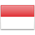
Indonesia: Independence Day

20th （２０日）
Estonia: Restoration of independence from Soviet Union

September ９月
1st （１日）
Uzbekistan: Independence from USSR

2nd （２日）
Viet Nam: Independence Day

Sep. 6th – 8th （９月６日〜８日）
China: Mid Autumn Holiday

7th （７日）
Brazil: Independence Day

15th （１５日）
Costa Rica: Independence Day

15th （１５日）
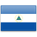
Nicaragua: Independence Day

16th （１６日）
Mexico: Independence Day

18th（１８日）
Chile: National (Independence) Day (Dieciocho)

September ９月、Continued

24th – 25th （２４日、２５日）
Pakistan: Eid-ul-Azha

October １０月
Oct. 1st – 7th （１０月１日〜７日）
China: National Day Holiday

3rd （３日）
South Korea: National Foundation Day

9th （9日）
South Korea: Hangul Proclamation Day

3rd （３日）
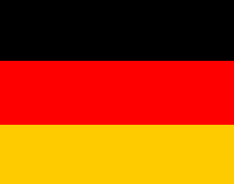
Germany: German Unity Day

10th （１０日）
Fiji: Independence Day

12th （１２日）
Japan: Health Sports Day

23rd （２３日）
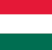
Hungary: Republic Day

October １０月、Continued

23rd （２３日）
Pakistan: Ashura

26th （２６日）
Austria: Declaration of Neutrality

November １１月

3rd （３日）
Panama: Independence Day

9th （９日）
Cambodia: Independence Day

9th （９日）
Pakistan: Iqbal

16th（１６日）
Japan: Culture Day

28th （２８日）
Panama: Independence from Spain

December １２月
2nd （２日）
Laos: Independence Day

5th （５日）
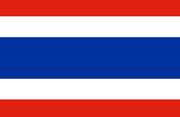
Thailand: Constitution Day

6th （６日）
Finland: Independence Day

9th （９日）
Tanzania: Independence Day

5th （５日）
Thailand: Constitution Day

16th （１６日）
Kazakhstan: Restoration of independence from Soviet Union

23rd（２３日）
Japan: Emperor’s Birthday

24th （２４日）
Pakistan: The Prophet’s Birthday

24th （２５日）
Pakistan: Quaid-e-Azam Day

December １２月, Continued

29th （２９日）
Mongolia: Independence Day

